Protocol: OPC isolation

In advance (or during tissue dissociation) coat flasks with Poly-D-Lysine (PDL) or Poly-L-Lysine (PLL)
- Coat flat bottomed 75cm flasks, with filter caps
- Stock concentration of PDL/PLL = 1 mg/ml aliquot and store in freezer
  - Use 50 µl from stock and dilute in 30ml sterile MQ
- Add enough to cover bottom of flask (6-10 ml) and place for at least 1 hour in incubator
- Wash once with water before use (it is not necessary to wait for the flasks to dry)

Dissection (P0 pups preferentially)
- Work in dissection room, wipe area with alcohol and sterilize instruments
- Required material
  - Dissection material (scissors, pincers,..)
  - Petridish for decapitation
  - Petridish for brain isolation
  - Petridish filled with DMEM placed under the microscope
  - 15ml tube with 1 ml DMEM/2 mice brains place on ice
- Decapitate animals and spray head with ethanol
- Remove the ears and pull skin over skull (until level of the eyes)
- Place one tip of scissors just under the skull, cut up from the back of the neck to the eyes (either side), avoid cutting into the brain
- Peel back skull and scoop out brain using small curved pincers and transfer to dish with cold DMEM
- With fine forceps, diagonally pinch the cerebral hemisphere away from the hindbrain/midbrain to collect the cortices (if necessary, transfer to new dish)
- Under dissection microscope, remove meninges with fine forceps (tip: start at hippocampus)
- Transfer cortices to 15ml tube on ice
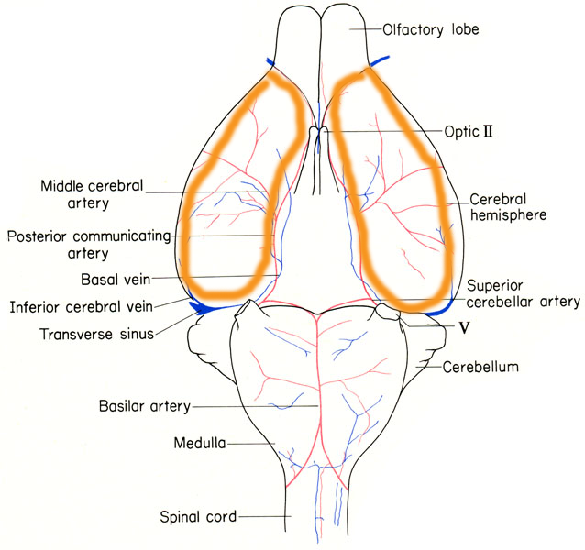
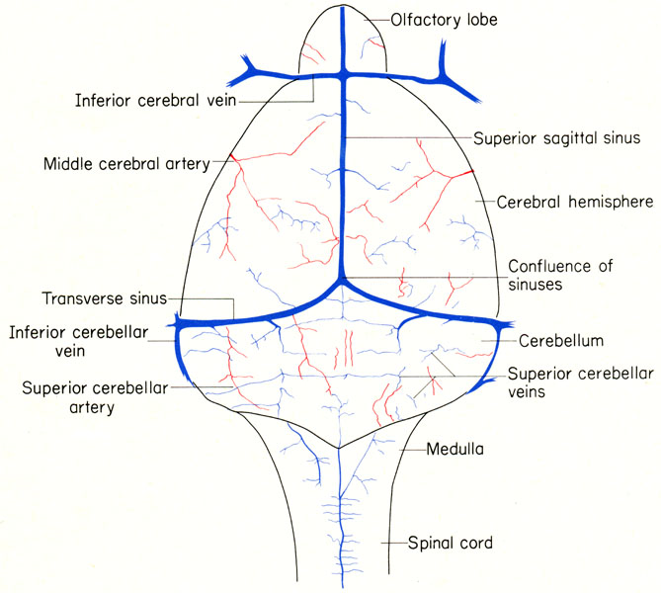
Papain solution for dissociating tissue
- Storage papain (20 Units/ml) in -80°C when dissecting last brain, place papain in warm water bath (stored in aliquots of 1ml, 1 ml is enough for up to 8 brains)
- Add DNase to papain solution (final concentration of DNase = 40 µg/ml)
- Place papain – DNase solution in incubator until needed
- Remove medium from cortices up to +/- 1ml on top of cortices
- Homogenise cortices by resuspending with P1000
- Centrifuge homogenised cortices for 5 min @ 300g
- Remove supernatant from pellet
- Add papain – DNase solution and place in warm water bath for 30 minutes (shake every 10 min)
- Inactivate digestion by adding 9 ml cold DMEM
- Centrifuge 5 min @ 300g
- Carefully remove most of supernatant, and resuspend in 2-5ml culture media (depending on number of brains)
- Triturate (gently!) a few times with a 21g needle
- Add 10 ml media
- Dilute cells as necessary to divide evenly between PDL-coated flasks (need to be 2 brains/flask)
- Replace medium at day 4, day 7 and day 11
  - Starting from day 7, add 5µg/ml insulin

Shake-off for OPC enrichment
- At day 14, the separation can be done of OPCs from monolayer of astrocytes
- Tighten cap of flask and tape shut with parafilm
- Agitate on 37°C heated orbital shaker for 45 min @ 75 rpm
- Aspirate and discard medium and add 10 ml fresh culture medium. This step removes the lossely adherent microglia
- Return flasks to shaker and continue shaking overnight (aim for 16-18h) @ 280 rpm
- Coat plates/glasses/wells with PDL/PLL where your experiments will be conducted in

- Remove medium next morning and place them on plastic petridish
- Incubate for 25-30 minutes and shake after 10-15 min. This step removes remaining microglia- they attach to plastic quickly, OPCs do not. Do not leave longer as OPCs will stick to plate and reduce yield in solution
- Collect media from dishes and pellet cells by centrifuging 5 min @ 300g
- Resuspend in appropriate culture media (proliferation or differentiation media)
- Triturate (gently, avoid bubbles) cells to break apart clumps with a 21g needle, followed by a 23g needle if necessary – it is important to have single cells for plating!
- Count cells
- Cells prefer high density for survival but too high and they differentiate prematurely and will not make myelin processes/membrane sheets
  - ICC: 150.000 cells/well – 24 well plate (coverslips)
  - qPCR: 250.000 cells/well – 24 well plate
  - WB: 500.000 cells/well – 6 well plate

Media & reagents
- Culture media
  - DMEM, high glucose (Life Tech 41966-029)
  - 1% Pen/strep
  - 10% FCS
  - (5µg/ml insulin )

- OPC proliferation medium (prevents differentiation: Sato + growth factors) (also ‘resets’ all cells to same starting phase)
  - 50 ml SATO without B27
  - 10 ng/ml PDGF (1000x, peprotech 100-13A-100µg)
  - 10 ng/ml FGF2/bFGF (1000x peprotoch 100-18B-250µg)
- Add growth factors (PDGF & FGF2 fresh, just before use)
- Need to add fresh growth factors daily (change media). Only keep cells for a few days in this media before using cells or switching to differentiation media (2-3 days)

- OPC differentiation medium (Sato - growth factors)
  - 50 ml SATO
- After 6-8 days, cells are differentiated in this media, don’t keep cells longer in here

- SATO
  - DMEM, high glucose 48 ml
  - Transferinne 120µl
  - Putrescine 50µl
  - Insuline 25µl
  - Progesterone 50µl
  - Sodium Selenite 37µl
  - TIT 50µl
  - L-Thyroxine 52µl
  - Pen/strep 250µl
  - Heat inactivated horse serum 1ml
  - B27 (growth factor) 1ml
- Media needs to be filtered afterwards (0.22µm)

